Dear Ellen Degeneres,

First and foremost let us introduce ourselves and give a little background knowledge as to who we are exactly. We are Dr. Alyssa Folk, Dr. Angie Park, and Dr. Katherine Mobbs and we are 2016 graduates from the University of California-Davis. As we were pursuing our college degrees(as seen below) we came to realize Zoology is really where our hearts lie. Our team all have PhDs in Zoology and have been working in the field of conservation for the past two years.

As skillful zoologists we felt compelled to reach out to you with our idea of building a sanctuary for mountain gorillas in the mountains of Rwanda. Rwanda’s large quantity of land gives us an ample amount of space to work with (as seen below). We are aware that you share our passion for gorillas, specifically mountain gorillas, as well as our shared role models Dian Fossey and Jane Goodall.

We were recently giving a lecture at Louisiana Tech University, standing in front of the fountain, “Lady in the Mist”, when the topic of our favorite book *Gorillas in the Mist* came to the surface. This helped in the development of our plan for our mountain gorilla sanctuary. We have agreed to build the sanctuary, because we believe mountain gorillas’ lives should be preserved for the future. This belief stemmed from one of our favorite inspirational quotes by Dian Fossey, stating “When you realize the value of all life, you dwell less on what is past and concentrate more on the preservation of the future.”

We particularly chose Rwanda mountains because it will be near your research facility. Our plan as a team is for the sanctuary to include an abundance of vegetation. Our team would also like for the gorillas sanctuary to have a swampy feel. The gorillas will be large in numbers as studies show that mountain gorillas typically live in cohesive groups and like to sleep in nests. Taking that into consideration logs and tree branches would best benefit a mountain gorilla. As well as a variety of plants bearing in mind that the mountain gorillas get the moisture they need from plants. The land for the sanctuary will be 15,000 acres. There will be a lush forest with lots of bedstraw.

As of right now the conservation status of mountain gorillas is critically endangered, and we have collectively agreed that building a sanctuary to help in the nourishment and the fulfillment of the gorillas would be in the species’ best interest. Our sanctuary will include top security in protecting the gorillas from possible threats: predators and humans. A research center will also be built to help study how to lengthen the lifespan of mountain gorillas. Mountain gorillas are significant in value to us, because it is one of the two subspecies of the eastern gorilla, additionally there are only two populations.

It is our hope that you can contribution $2 million to make this partnership possible. Ellen, together we can dance with gorillas!

Thank you for your time,

The Gorilla Saviors

Alyssa Folk, Phd.

Angie Park, Phd.

Katherine Mobbs, Phd.

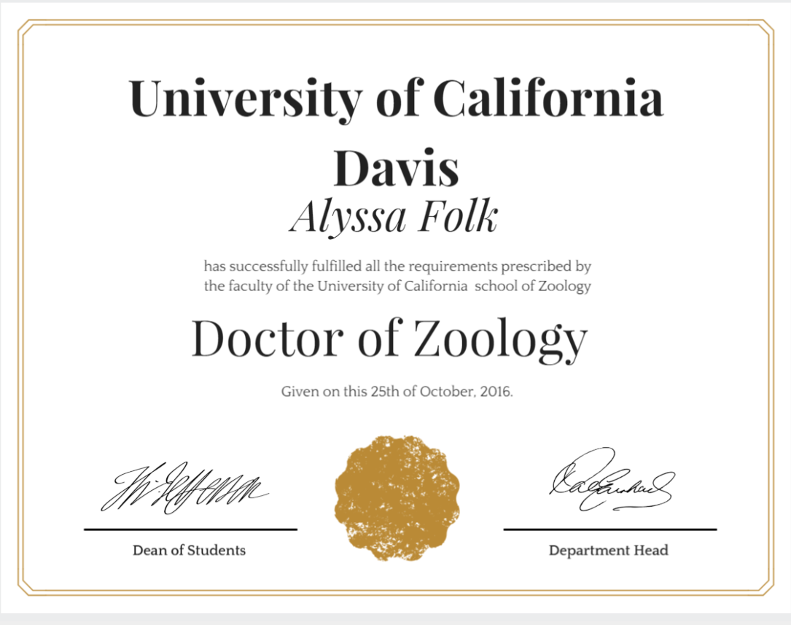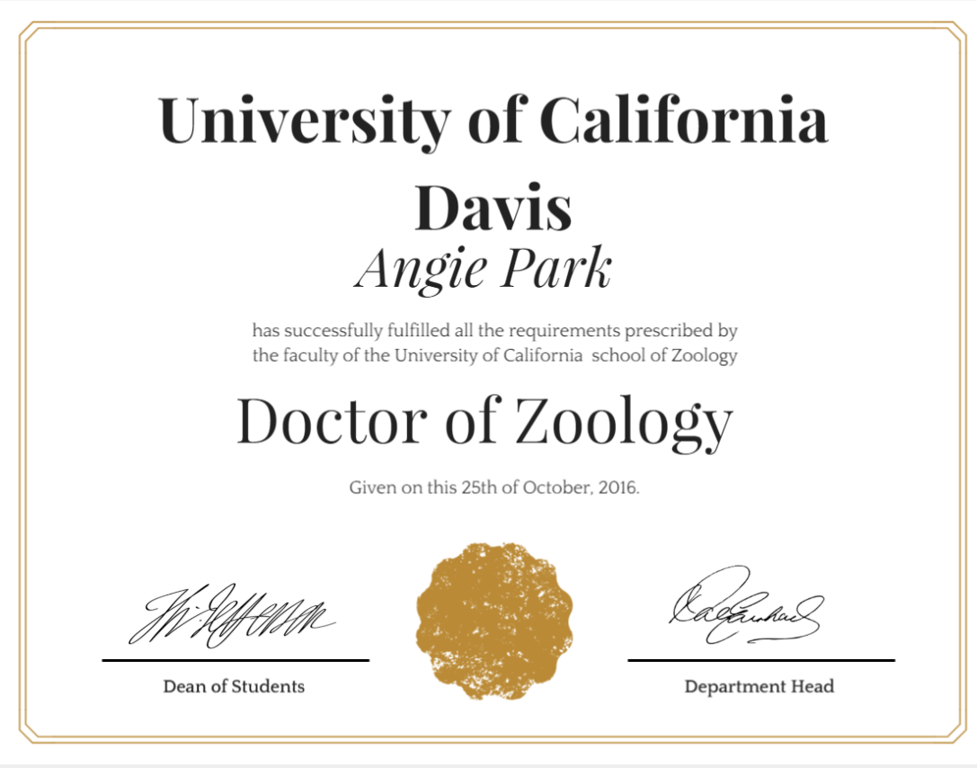

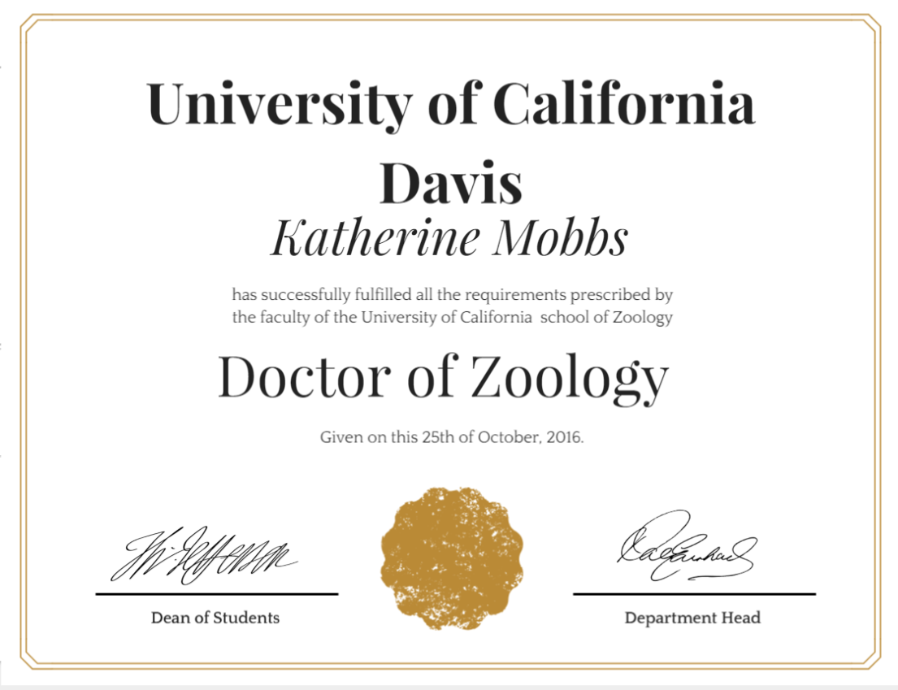

Future Home of Our Gorilla Sanctuary

